**­DHL Golden Ticket - AG Barr: Workshop Summary**

**Exploring the voice of the customer – key themes:**

|  |  |
| --- | --- |
| **Your voice of the customer headlines** | **Key themes** |
| 1. DHL are the perfect strategic partner to unlock our growth and sustainability ambitions. – **CEO/CFO** 2. DHL are a trusted, resilient partner. Our aligned goals create a sustainable future and shared growth. – **SC director, TC director, C-suite** 3. DHL are our partner of choice to drive growth with scalability, green transport, and alternative fuels. – **CS officer, Carl Donnan** 4. DHL meet all our needs, beyond supply chain, understanding ambition and driving growth across our business. – **SC director** 5. DHL listen, innovate in proposals, understand our fundamentals, and remain trusted, competitive, and valuable in pricing. – **SC director** 6. DHL want to partner with us and will invest in the relationship to enable growth. – **CEO, SC officer** 7. DHL are a strategic partner enabling us to maximise our growth potential. – **SC director** 8. DHL provide everything we need now and are the partner we trust to grow with. – **3PL Partner, Greg Dowdor, SC director** 9. DHL lead in sustainable transport with expertise to help us grow and transform our business. – **CEO** 10. DHL listened, offered growth options, fully understand our business, and see us as a key strategic partner. – **SC director, TC director** | * Strategic growth partner * Sustainability leadership * Trusted and resilient partner * Scalable solutions for growth * Commercial innovation & agility * Deep customer understanding * Long-term value creation * Investment in partnership * Operational excellence * People and collaboration * Future-ready expertise |

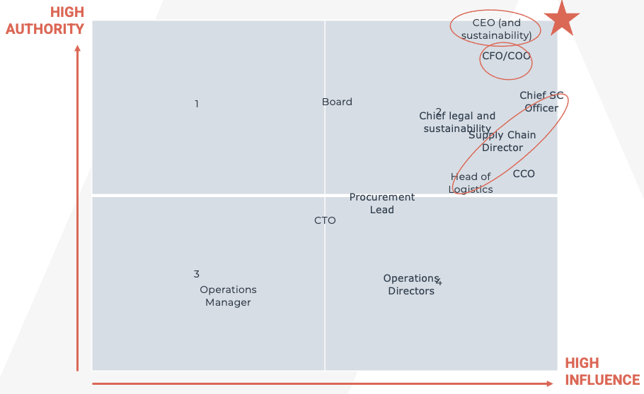

**Defining the decision making unit:**

**Decisions makers:**

CFO/COO, Chief SC officer, CEO, Head of logistics, Supply Chain Director

**Wider influencers:**

Chief of legal and sustainability, Board, CTO, Operations Manager, CCO

**Wider community:**

Procurement lead, Operations Manager, Operations Director

**Three confirmed audience groups with key priorities and themes:**

|  |  |  |  |
| --- | --- | --- | --- |
| THEMES | Supply Chain Officer | CFO/COO | CEO (and sustainability) |
| TOP 3 PRIORITIES | **Production continuity: keep manufacturing running without disruption**  **Infrastructure readiness: capacity that meets current and future needs**  **Growth capacity: scalable solutions that that enable expansion** | **Growth ambitions: realised with maximum operational effectiveness**  **Retailer service agreements: met to avoid penalties and reputational risk**  **Sustainability goals: progress on scope 3 reductions, enabling focus on scope 1 and 2** | **Business** **growth:** delivered in the ‘right way’  **Resilience:** supply chain able to adapt through change  **Brand protection:** confidence in the partner to reduce risk |
| ALL OTHER THEMES | **Space constraints alleviated** so focus stays on brands and production  **Visibility and control** through data and scalable, sustainable sites  **Green credentials** to meet consumer preferences and support sustainable brand growth  **Lower investment risk** with flexible, phased growth | **Capital efficiency – we invest, they gain pay-as-you-grow flexibility and stronger returns**  **Investor confidence from robust forecasts and market stability**  **Scalability aligned to acquisitions, with solutions fit for purpose to hit agreements**  **Financial stability underpinned by disciplined capital investment** | **Peace of mind** from a collaborative relationship, support through change and growth at their pace  **Ambitions** aligned with solutions 100% adapted to needs  **Flexible network access** and sustainable transport including RES  **Reassurance** through proven impact and trusted partnership |

**Defining our points of difference that matter:**

* **Sustainability in motion** – As the first logistics provider to commit to science-based targets, with Ecovadis silver/gold ratings and low-carbon transport, we help customers deliver ESG commitments credibly.
* **Clarity without compromise** – Our open-book culture and data-driven platforms give customers real-time visibility into performance, ensuring accountability and trust across the supply chain.
* **One system, every solution** – From transport to co-packing, procurement and design, our single-provider model integrates services into one accountable solution, reducing complexity and boosting efficiency.
* **Future powered today** – Backed by major investments in assets, technology and digital tools, we deliver solutions that transform operations and keep customers ahead of industry change.
* **Catalysts of transformation** – With a proven track record enabling change for brands like Mars and Sainsbury’s, we act as a trusted partner guiding ambitious agendas with confidence.
* **Resilience without compromise** – Recognised for cyber security and operational excellence, we deliver reliable supply chains that withstand disruption and protect business continuity.
* **Infrastructure for tomorrow** – Beyond traditional supply chains, our ability to design and build facilities to exact requirements (through RES) delivers scalable, future-ready solutions aligned to growth.
* **Credibility you can count on** – Independent recognition, including Gartner Magic Quadrant placement and major investments, reinforces industry leadership and trust in our capabilities.
* **Human advantage** – With strong EOS scores, HR-led initiatives and DHL Foundation commitments, we attract and retain talent while embedding a culture of consistent excellence.
* **Built around your success** – Our brand promise is to make customers successful, combining bold ideas with tailored solutions that align with long-term ambitions over short-term transactions.

**Summary of key areas identified for exploration in the value proposition:**

1. **Unlock scalable growth** with warehousing, transport, and infrastructure solutions that flex with business needs and enable brand expansion.
2. **Guarantee operational resilience** through reliable service, cyber-secure supply chains, and proven risk management in high-demand environments.
3. **Lead sustainability transformation** with science-based targets, net-zero warehousing and low-carbon transport solutions that build green credentials.
4. **De-risk investment** with ‘pay as you grow’ models that reduce capital exposure and unlock new growth opportunities.
5. **Build a trusted partnership** grounded in trust and shared value creation, enabling growth at pace through change.